SQL - Supply Chain Case Study

“Richard’s Supply” is a company that deals with different food products. The company is associated with a pool of suppliers. Every Supplier supplies different types of food products to Richard’s supply. This company also receives orders for food products from various customers. Each order may include multiple products, each with a quantity. The company has been maintaining the database for 2 years.

Refer to the following Entity-Relationship diagram of the database
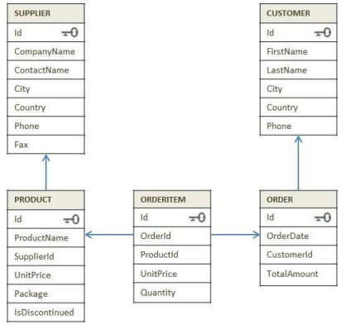
Instruction to create a supply chain database:

- Find the country-wise count of customers.
- Display the products that are not discontinued.
- Display the list of companies along with the product name that they are supplying.
- Display supplier ID who owns the highest number of products.
- Display month-wise and year-wise counts of the orders placed.
- Which country has the maximum number of suppliers?
- Which customers did not place any orders?
- Arrange the Product ID and Name based on the high demand by the customer.
- Display the total number of orders delivered every year
- Calculate year-wise total revenue.
- Display the customer details whose order amount is maximum including his past orders.
- Display the total amount ordered by each customer from high to low.
- Fetch the customer details who ordered more than 10 products in a single order.
- The company sells the products at different discount rates. Refer actual product price in the product table and the selling price in the order item table. Write a query to find out the total amount saved in each order then display the orders from highest to lowest amount saved.
- Create a combined list to display customers' and suppliers' details considering the following criteria
  - Both customer and supplier belong to the same country
  - Customers who do not have a supplier in their country
  - A supplier who does not have customers in their country

